Character Information

Christopher Hall & Riley Boyd

991 290 303 & 991 381 233

Project Information:

We are going to be creating a program where you can view everything about different characters in a game. You can see what race, class they are and some stats such as agility, strength, intelligence and critical hit percentage. This program would be useful for any person playing the game who wants to look at their stats. The main purpose of this program is to allow a player to look up their characters stats or other characters who are also in the same game.

Data Type & Description:

|  |  |  |
| --- | --- | --- |
| Description | Data Type | Comments |
| Race | String | Character race (elf ,troll ,human ,orc) |
| Class | String | Character Profession (warrior, hunter, mage) |
| Strength | Double | Attack power |
| Agility | Double | Speed of Attack |
| Intelligence | Double | Mana based attack power |
| Critical Hit % | Int | Percentage to do extra damage |

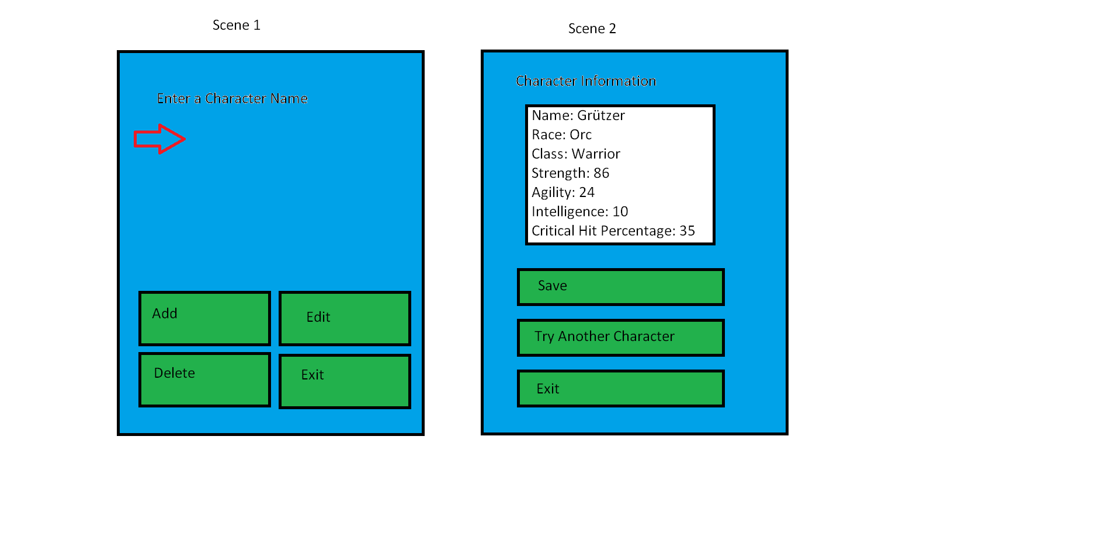

Data Area

Buttons

Input Area